# Foreword

The following document is awful, it took next to no effort and the majority of the work was done by the kind folks over at the TARDIS Wikia. I have shamelessly borrowed their words and added my own snark to them. Still, as terrible as this special was, I do believe that it could have some value to the game. Please skip to **Running the Adventure** to get straight to that point.

# History of the Special

Dimensions in Time was a two-part story broadcast in 1993 as a part of that year's Children in Need appeal. It featured Kate O'Mara's last televised performance as the Rani.

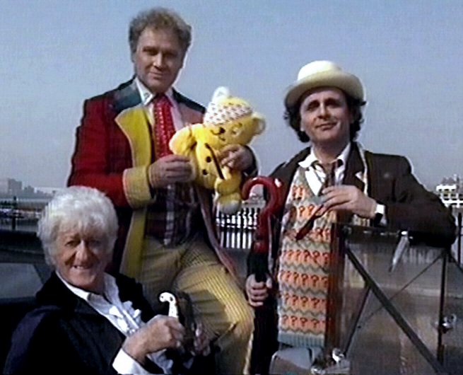It was a nominal "celebration" of the thirtieth anniversary of Doctor Who, made primarily due to the cancellation of the BBC's original idea for a thirtieth anniversary s tory, The Dark Dimension. Since the BBC had already obtained agreement from most of the ex-Doctors to do some sort of anniversary programme, they went ahead with a charity sketch. Dimensions raised over £101,000 for Children in Need according to presenter, Noel Edmonds.

A major narrative feature of the piece was that it featured a crossover between the EastEnders and Doctor Who universes; that is, the characters were narratively implied to be a part of the same universe. As the years have gone by, this narrative choice has caused the piece to be disregarded by many fans. Largely ignored by both Doctor Who and EastEnders writers, Dimensions became widely irrelevant to both series.

Dimensions was a milestone production in several ways. It was the first and only time that John Nathan-Turner received a writing credit on a televised story. It was also the final BBC1 appearance for most of the Doctor Who characters involved, the first time in Doctor Who history that 3D technology had been used in the recording and broadcast of a television story and the first time that the televised audience were able to affect the outcome of a Doctor Who story by telephone vote.

Despite its many noteworthy qualities, it was all-but universally panned. Summarizing general fan attitudes, Stephen J. Walker, David J. Howe and Mark Stammers gave it a 0/10 and called it "a dreadful travesty of a Doctor Who story". Perhaps most clearly, Nathan-Turner said that he regarded it as outside the continuity of the series, noting that "it was never intended to be a part of the Doctor Who mythos, whatever that means" and that he "couldn't care less" whether it was included alongside other episodes in lists of Doctor Who serials.

# Synopsis

London 1973, 1993, and 2013

The Rani plans to create a menagerie assemble form all the known sentient creatures from throughout all of time and space. With the help of her companion, Cyrian, she has a Z ygon, a Cyberman, a Dalek and even a Time Lord ensnared within her cages, which she apparently keeps behind the roundels in her TARDIS. That’s right, she’s sullied the Round Things.

Using her devious mind and a plan that is lacking quite a few supporting details, the Rani intends to use the menagerie to gain control of all the individual minds in the universe. She only requires one last specimen, a human from Earth. Knowing that the Doctor will attempt to stop her, she creates a temporal trap to ensnare the Doctor in all of his incarnations.

The Fourth Doctor (showing up via the power of blue screen and sporting a overlarge hat and a severe lack curls, but it is better than a waxwork and footage from Shada) attempts to send a warning to his previous and future incarnations, alerting them to the Rani’s threat. Unfortunately for the Doctor’s Fourth Incarnation he is presumably captured by the Rani as he is never seen in the story again (way to phone it in Tom). The Fourth Doctor’s message is diverted and the Rani seizes control of the Seventh Doctor’s TARDIS.

The Seventh Doctor and Ace were en route to China, but find themselves materializing in Cutty Sark Gardens in London, 1973. As they walk the Doctor turns into his sixth incarnation, shocking Ace. The Sixth Doctor comes to the conclusion that they must have encountered a groove in time. Continuing their search, Ace discovers that they have jumped forward 20 years to 1993.

Suddenly, Ace is replaced by Mel and the Sixth Doctor becomes the Third. The Doctor explains to Mel that someone has been going through his timeline, pulling out early versions of himself and his companions. He meets two old shop owners who are selling what he sees as over-priced fruit. The Doctor learns that the year is 2013 just before he jumps in time again.

They find themselves jumping time tracks between the years 1973, 1993 and 2013, in an area within a few miles of Albert Square in London's East End. The Doctor is also changing back and forth between his Third, Fifth Sixth and Seventh incarnations, while Ace keeps being replaced by varied past companions. Worse, the Rani has released her menagerie — including an Aldeberian, an Argolin, a biomechanoid, a Cyberman, a Stigorax, a Mentor, an Ogron, a Sandminer robot, a Sea Devil, a Tetrap, a Time Lord, a Tractator, a Vanir and a Vervoid — to attack the Doctors and their companions. The Rani tells the Doctors that they're all going on a journey — a very long journey!

The Rani is confronted by the Fifth Doctor, who psychically summons the Third Doctor to take his place. Liz Shaw attempts to disarm her, but flees when the Time Lady is distracted by a young woman.

The Third Doctor is fortuitously rescued by Bessie, being driven by Mike Yates, who shoots the Rani's gun out of her hand and takes the Third Doctor to a helicopter, where he meets the Brigadier. After turning into the Sixth Doctor, he departs to find his companions.

The Rani, now in her TARDIS, proclaims she only needs one more human to complete her menagerie, and sets a course for the Greenwich Meridian. Discovered by a pair of men, Romana II leaves her hiding place to find the Doctor, but is instead dragged into the Queen Vic pub.

The Third Doctor makes it to the TARDIS with Victoria, and, emerging from the TARDIS in his seventh incarnation, sees the Rani's TARDIS materializing and witnesses Leela escaping from it. Leela tells him about the Rani's menagerie of clones, and he explains how the Rani is attempting to transfer a massive Time Tunnel to the Greenwich Meridian. Realizing that the Rani is attempting to gain control of evolution, he asks Leela what form she was in when the Rani cloned her, and realizes that, given the fact that the Rani cloned Romana, there are now two Time Brains in the Rani's computer.

The Seventh Doctor sets out to override the Rani's computer, and harness the power of the Time Tunnel to pull in the Rani's TARDIS instead of his own. He uses his psychic powers to join with his earlier incarnations, then uses a converter linked to the dual Time Brains in the Rani's computers to propel her TARDIS into her own trap. Having freed himself, his past incarnations and all their companions, the Doctor and Ace depart.

# Running the Adventure

In many ways, **Dimensions in Time**, is quite possibly the worst thing to ever happen in the history of Doctor Who. It features a nonsensical plot, a menagerie of villains that do nothing at all and for some unknown reason it’s an East Enders crossover.

So why does this document exist?

In broad strokes this seems like a fun one shot adventure for the RPG Table. It’s a musical chairs of character sheets, a bonkers villain, an evil plot that can only be improved by any game master, and it’s full of *timey wimey* jumping about.

In order to run this adventure you need, heaps of character sheets, an abundance of snarky sarcasm, and the ability to laugh at the tropes of the show. You can also probably drop the entire Eastenders subplot.

# Cast of Characters

There are nearly no new characters to add from this adventure. In fact there’s only one worth adding, Cyrian, the Rani’s companion.

## Cyrian

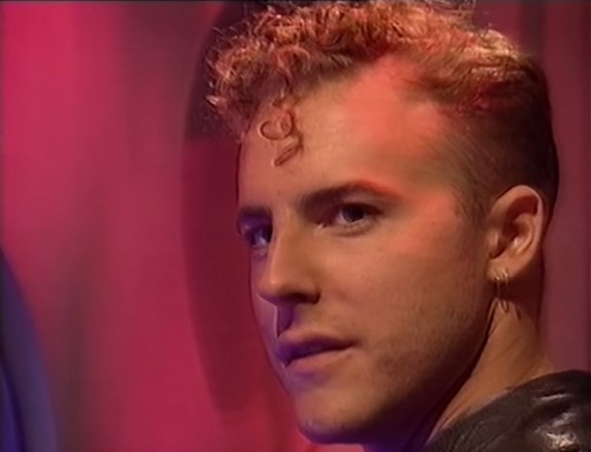Cyrian’s background is largely inferred as he’s essentially useless and his only other appearance is in the Doctor Who 1993 year book which documents how he met the Rani. I haven’t read that and am just sort of making up another equally vague backstory for this more or less blank face of a character.

Cyrian was born in the year 2467 on the planet *John* in the binary star system Nathan-Turner. This was a standard M-Class planet and Cyrian grew up in a fairly normal life. He didn’t have many friends and his grades weren’t that great. In 2488 he joined the crew of the NXCC Misguided Nostalgia as a Waste Management technician. It wasn’t a great job, but it paid decently and came with health insurance. In a disaster, that could arguably be attributed to a technical malfunction, the NXCC Misguided Nostalgia crashed into the small moon of Charity Sketch.

The Rani had been doing her initial experiments with her plan regarding her universal menagerie when Cyrian’s ship crashed. She saved him from the wreckage when she realized that a disposable minion could be a useful resource.

|  |  |  |  |  |  |  |  |  |  |  |
| --- | --- | --- | --- | --- | --- | --- | --- | --- | --- | --- |
| **Awareness** | **Coordination** | | | **Ingenuity** | **Presence** | | **Resolve** | | **Strength** | |
| 3 | 3 | | | 2 | 4 | | 3 | | 3 | |
| **Athletics** | | | 3 | **Convince** | | 2 | **Craft** | | | 0 |
| **Fighting** | | | 3 | **Knowledge** | | 3 | **Marksman** | | | 2 |
| **Medicine** | | | 0 | **Science** | | 4 | **Subterfuge** | | | 0 |
| **Survival** | | | 3 | **Technology** | | 3 | **Transport** | | | 2 |
| **Tech Level** | | 6 | | | **Story Points** | | | 12 | | |

Good Traits

* Animal Friendship(Major)
* Time Traveler (Minor)

Bad Traits

* Outcast (Minor)
* Owes Favor (Major) – The Rani saved his life.

## Cast List – Use Official Stats, or Siskoids, or Who Cares Really

* Seventh Doctor - Sylvester McCoy
* Sixth Doctor - Colin Baker
* Fifth Doctor - Peter Davison
* Fourth Doctor - Tom Baker
* Third Doctor - Jon Pertwee
* The Rani - Kate O'Mara
* Ace - Sophie Aldred
* Susan Foreman - Carole Ann Ford
* Brigadier Lethbridge-Stewart - Nicholas Courtney
* Romana II - Lalla Ward
* Sarah Jane Smith - Elisabeth Sladen
* Nyssa - Sarah Sutton
* Leela - Louise Jameson
* Peri Brown - Nicola Bryant
* Melanie Bush - Bonnie Langford
* Voice of K9 - John Leeson
* K9 Operator - Matt Irvine
* Liz Shaw - Caroline John
* Mike Yates - Richard Franklin
* Victoria Waterfield - Deborah Watling
* Gita Kapoor - Shobu Kapoor
* Grant Mitchell - Ross Kemp
* Phil Mitchell - Steve McFadden
* Sharon Watts - Letitia Dean
* Frank Butcher - Mike Reid
* Pauline Fowler - Wendy Richard
* Vanir - John Frank Rosenblum
* Mandy Salter - Nicola Stapleton
* Pat Butcher - Pam St. Clement
* Kathy Beale - Gillian Taylforth
* Sanjay Kapoor - Deepak Verma
* Big Ron - Ron Tarr (scenes not shown in televised version)
* Cyrian - Sam West
* Ian Beale - Adam Woodyatt, Tim Handel
* Sea Devil - Michael Fillis
* Ogron - Derek Handley
* Tractator/Tetrap/Zog/Dragon Operator - Martin Wilkie
* Argolin - Anthony Hopkinson
* Cybermen - Tony Kirke, David Miller
* Fifi operator - Stephen Mansfield
* Kiv - Philip Newman
* Mawdryn mutant - Paul Lunn
* Mogarian - Steven Coats
* Ogron - Derek Handley
* Plasmaton - Tim Packham
* Ruffian - Alan Cave
* Sea Devil - Mike Fillis
* Time Lord - Andrew Beech
* Vanir - J.F. Rosenblum
* Vervoid - Anthony Clark
* Robot - Ilona MacDonald